**UNIVERSITY INSTITUTE OF COMPUTING**

PROJECT REPORT

ON

MAHINDRA CAR SHOWROOM MANAGEMENT SYSTEM

Program name: BCA

Subject name/Code: Data Management System (23CAT- 251/23CAP-252)

Submitted by: Name: Vansh Kumar ID: 23BCA10471



Section: 23BCA- 4(B)

Submitted to:

Name: Mr. Arvinder Singh

## ACKNOWLEDGEMENT

We express our heartfelt gratitude to our mentor Mr. Arvinder Singh for his continuous support and guidance in the development of the Mahindra Car Showroom Management System. His expertise in

database design and SQL programming significantly shaped the success of this project.

## INTRODUCTION

*Overview*

The Mahindra Car Showroom Management System is a relational database solution built to streamline showroom operations, manage

vehicle inventory, sales, employees, customer data, and financial transactions. The system ensures real-time access to vehicle stock, test

drives, bookings, sales reports, and customer feedback.

## Importance of DBMS in Car Showrooms

Managing a large inventory of vehicles, staff, and customer information requires an efficient and reliable DBMS. It helps eliminate redundancy, supports better customer service, optimizes sales tracking, and secures vital transaction data.

**OBJECTIVES**

 **Vehicle Inventory Management** – Track available cars, specifications, and stock levels.

 **Customer Records** – Store customer details, preferences, and history.

 **Sales Transactions** – Manage invoices, payments, and purchase details.

 **Employee Management** – Maintain sales staff information and performance records.

 **Service and Test Drive Booking** – Log test drive appointments and service records.

 **Operational Reports** – Generate sales reports, inventory status, and customer insights.

**SYSTEM FUNCTIONALITY**

Built on a relational DBMS, the system uses foreign keys, primary keys, and normalization to maintain integrity and support complex queries. Main tables include:

Cars

Customers

Employees

Sales

TestDrives

Services

Inventory

 Showrooms

**TECHNOLOGIES USED:**

DBMS: MySQL

**ER Diagram**

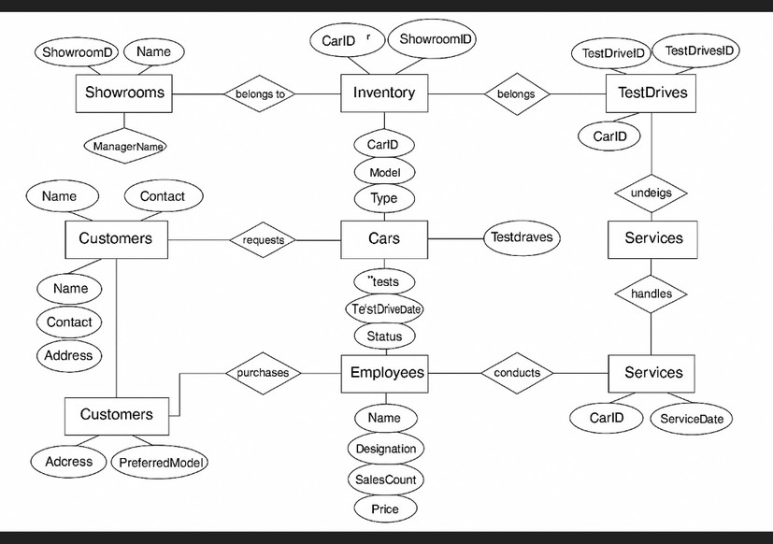

**Tools**:

MySQL Workbench

🌟 Expected Benefits

✅ Real-time Inventory Updates

Track stock automatically to avoid shortages and excess.

✅ Efficient Sales Management

Speed up billing, order handling, and daily transactions.

✅ Customer Relationship Tracking

Build stronger bonds through organized customer records.

✅ Streamlined Service Scheduling

Easily manage appointments for smooth operations.

✅ Detailed Analytical Reports

Gain valuable insights with clear, data-driven reports.

**ENTITY DETAILS & INPUTS**

# **Cars:** Model, Type, Engine, Price, Availability

 **Customers:** Name, Contact, Address, Preferred Model

 **Employees:** Name, Designation, Sales Count

# **Sales:** CarID, CustomerID, SaleDate, Price

 **TestDrives:** CustomerID, CarID, Date, Status

 **Service:** CarID, ServiceDate, Cost, Description

 **Inventory**: CarID, Quantity, ShowroomID

 **Showrooms:** Name, Location, Manager